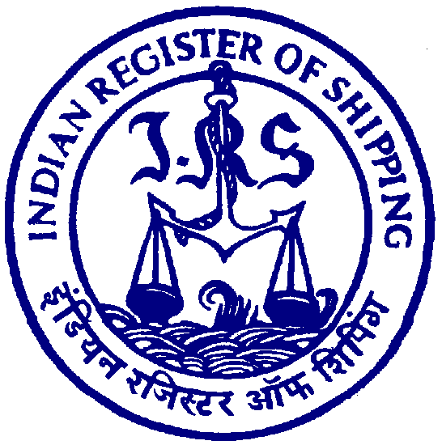
No.: 018/2024 Date: 10th September 2024

Technical Circular

Subject: Concentrated inspection campaign (CIC) by Riyadh MoU on Ship Lifting Appliances beginning from 1st September 2024 and ending on 30th November 2024.
- A Concentrated inspection campaign (CIC) on Ship Lifting Appliances has been initiated by the member Authorities of Riyadh Memoranda of Understanding (MoU) on Port State Control.
- The inspection campaign will be held for three (3) months, commenced from 1st September 2024 and ending on 30th November 2024.
- The purpose of the CIC is to ensure that ship crew members:
• are properly trained and are familiar with the different types of crane equipment;
• can spot any potential hazards in a timely manner;
• know what actions to take in the event of an emergency;
• have the necessary qualifications for their specific roles;
• have access to up-to-date safety manuals that set out best practices for each task; and
• perform periodic maintenance on the ships' lifting equipment and devices.
- During the campaign period, member Authorities of the Riyadh MOU will inspect within the resources available, as many ships as possible in conjunction with routine port State control inspections, each ship will be subject to only one inspection under this CIC during the period of the campaign.
- Port State Control Officers (PSCOs) will use a list of 10 questions to assess the adequacy and adherence of Ships Lifting Appliances and equipment to the relevant requirements, that the master and crew members are familiar with operations relating to Ships Lifting Appliances, and that equipment is properly maintained and functioning.
- Deficiencies found during the inspection will be recorded by the PSC officer and actions may vary from recording a deficiency and instructing the master to rectify it within a certain period of time, to detaining the ship until serious deficiencies have been rectified.
- Accordingly, Owners and managers of the Shipping Companies are advised that the ship’s Masters are communicated to ensure that fire doors are maintained properly onboard and comply with the relevant requirements.

Enclosure:
- ST KITTS & NEVIS Maritime Circular- MC 133 24

